This directory contains the Matlab code and test data for correcting drift during a time lapse movie. This is suitable for images containing multiple small features that can potentially complicate the alignment.

How to use Correct_image_alignment:

1. Preliminary steps: prepare two separate folders, one containing the original images (for example, the “ref” folder containing test data) and the other for the analysis results (empty).
2. Copy the directory path and paste into the editor window in Matlab- first line contains the path for original data, the second contains the path for analyzed data.
3. For the Reference_image, copy the name of the first image from the original data and paste after the ref directory (the path to the folder/image full name.tif).
4. Run.
5. In the image window, mark with a square a distinctive object which is preserves its location throughout the entire movie (see Fig.1). This object will be used for alignment.
6. Import to fiji the aligned images and save as new stack.

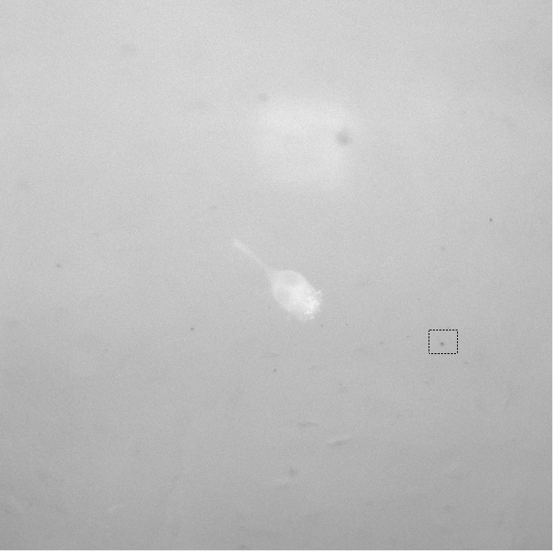

Fig.1: Exemplary image demonstrating the object marked in step 5.